|  |  |
| --- | --- |
| Wede5020 poe  Part 1 | About?  This document will explain in detail in what is to be seen with in the website and contains a Table of content, Description, Graphical items used in the website and the web pages included in the website with a list of references used  Jayden guilherme  ST10286666 |

# ***Table of Contents***

# Table of contents

*Table of contents* 1

*Website Choices* 2

*Website Assets* 3

*Website Pages and Content* 4

*Reference List* 5

# ***Website Choices***

Websites Name:

After a thorough thought process, I decided to go with Solving Environmental Problems (SEP) as I thought that the heading was suitable for the type of NGO that I was going for as it related to the topic and had a catchy name which could draw attention to viewers.

Descriptions:

Solving Environmental Problems (SEP) does exactly as the name states as my NGO is about solving the environmental problem dealing with the amazon rainforest. With greats amount of research done on the NGO I was blown a way by numerous things that occur in the amazon. The amazon deals with a large portion of its trees being deforested as well as many animals dealing with the loss of habitats and lack of food source. Not only animals but the indigenous people of the amazon rainforest have lost their source of food and must relocate their homes.

A lot of the animals that have inhabitants in the rainforest have to deal with caution of them becoming an extinct species. Examples being capybara, blue macaws and South American tapir, I want to use this website to help gain the attention and help for the amazon rainforest. An example of this being donations and planting a tree within the rainforest and recycling paper as well as hard labour being used in a way to help plant food and repair the habitats for both animals and indigenous people.

By spreading awareness my organisation I believe that we can regrow, rebuild and develop the ecosystem of the amazon rainforest to a better state. To sum up what has already been stated in the descriptions above my website is here to spread awareness and help the rainforest from becoming deforested.

Reason:

The reason for choosing the topic as my NGO is that the environment plays a important role in our life’s as well as the other lives of the animals in our eco system and we never pay attention to it. But my reason for choosing the amazon rainforest is that people who support the eco system normally focus on the ocean or recycling plastic or protecting endangered animals, but the amazon isn’t a very often spoken topic compared to other NGOs.

The amazon produces lot of paper, trees and a lot of fruit e.g., Coconut and pineapple. Which is essential to the earth as trees produce oxygen and by deforesting the amazon, we are taking away the oxygen and other items which get produced. Especially many major farms for fruits and vegetables.

In conclusion, my reasoning for helping the rainforest is that it is not a mainly often spoken topic and I want to spread awareness about the rainforest and the essentials which get produced from it.

# ***Website Assets***

|  |  |
| --- | --- |
| **Use** | Image |
| The use of this image is the design of my logo that what created using a free open-source software called Canva |  |
| Used in the main webpage for information and decoration |  |
| Used in the Species page and indigenous people Page to allow information on what species is extinct |  |
| Used throughout the website for decoration and information |  |

# ***Website Pages and Content***

Home Page:

The main page is where the basic data will go where the viewer can see pictures and navigate to the chosen topic they will select as well as the viewer can see the main content of NGO.

About:

The about page will be explaining the topic in great detail on different sections of the topic e.g., Recycling methods, How to help, More detail in what is happening in the rainforest and the inhabitants of the rainforest.

Contact:

The contact page will provide the user with different contact details for different sections of the NGO e.g., Email and Phone number as this will allow the viewer to engage and ask for information to be given to them just be contacting the numbers.

Donations:

The Donation page allows the user to send donations to the NGO or sign up to register for helping the NGO plant food for the habitats and repair it as well as planting trees.

Species:

The Species page will allow the user to gain knowledge on all species that are endangered at the rainforest which will have an image as well size height, name, habitat and description of the animal.

Indigenous People:

The indigenous People page will allow the viewer to gain knowledge on the people who live I the forest by providing pictures and descriptions on the tribe and what the people do in the rainforest.

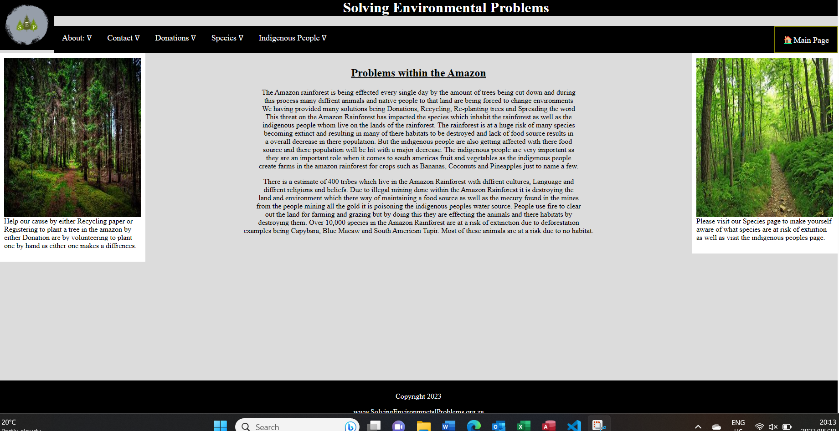

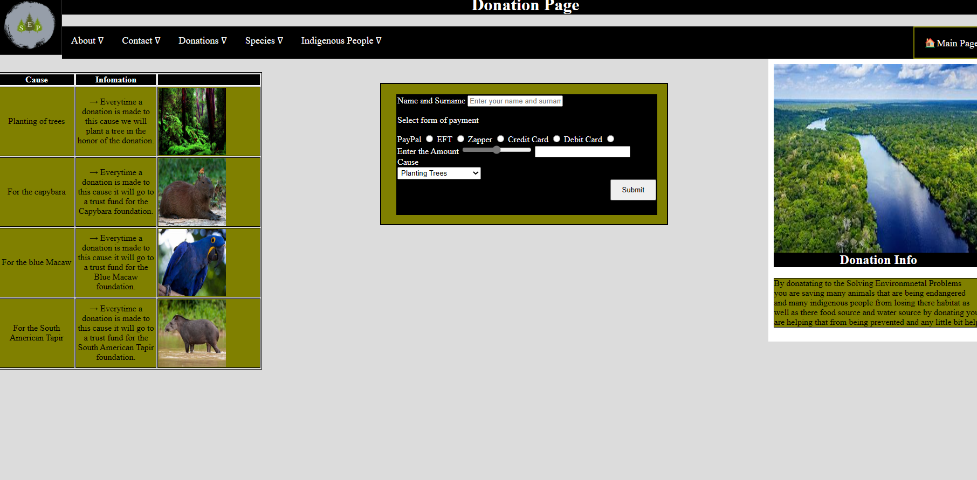

# Part 2

# Improvements to part 1

* Added Navigation Bar to Every webpage.
* Realigned table in about webpage using position relative.
* Added a registration table in the donation page.
* Added a main page link to nav bar.
* Realigned the Table in the contact page.
* Realigned the Table in Indigenous people page.
* In the species page made the images of species realigned
* Added a button in registration form that sends the user an alert that “the donation has successfully gone through”.
* Added a radio to the registration form to pick the form of payment.
* Added a Slider and added JavaScript to the slider to allow the sliders number to be displayed in the text box next to it
* Added a gradient background to the homepage link and a symbol
* Added Responsive Webpage.

# ***Reference List***

# References

Britannica, 2023. *Amazon Rainforest.* [Online]   
Available at: https://www.britannica.com  
[Accessed 21 march 2023].

Palotoa Amazon Travel, 2014. *10 endangered species of amazon rainforest.* [Online]   
Available at: http://palotoaamazontravel.com  
[Accessed 24 march 2023].

World Wide Fund for Nature, 1961. *Learn About the amazon rainforest.* [Online]   
Available at: https://www.wwf.org.uk  
[Accessed 26 march 2023].

World Wide Fund for Nature, 2023. *WWF South Africa.* [Online]   
Available at: https://www.wwf.org.za  
[Accessed 21 March 2023].